OVID Technical Outline

Michel Johansen, [m.jjohansen@synoki.com](mailto:m.jjohansen@synoki.com)

March 11, 2021

# Overview

The platform, currently called “Ovid” after the poet who wrote the Greek myth of Narcissus, will provide user’s with an interlinked social media platform to share their purchases with their circles and promote products. Sponsored products will provide a chance for users to earn income when their links are used to purchase an item they have promoted. Marketers will be able to track the purchases made through the system and the influencer’s that are responsible for driving their traffic. This allows Marketer to mange their social media campaigns and place their marketing dollars where they see a return.

The connection between different social media account, using public API’s and User’s permissions, allows the system to target the friends and followers of a vast user group. Analytically data regarding buying habits, social links and product endorsement will provide marketers with the data they need to generate new campaigns and companies with time critical information on product offerings.

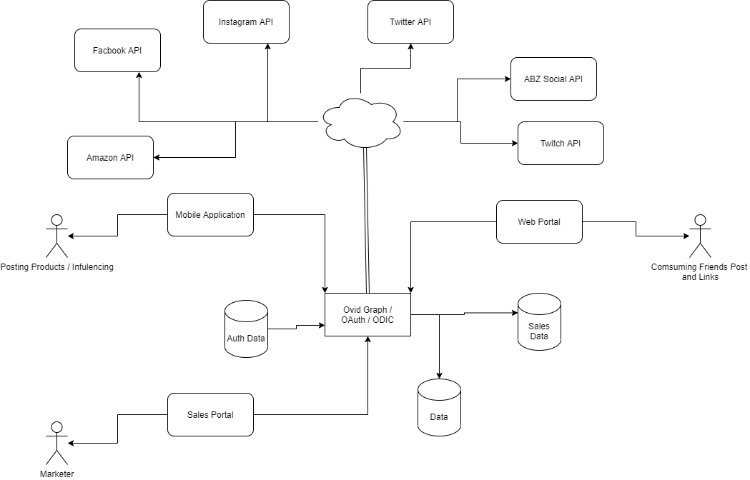

Figure System Overview

# Architecture

The majority of the business logic and data logic is provides by the GraphQL API hosted on the main site subdomain. “graph.domain.com” is the main entry point for both the mobile and web based applications. When requesting data or preforming a mutation the application will hit the GraphQL endpoint. Authorization and Authentication is handled by the IdenityServer4 running either on the same address to reduce IP endpoints, or on a subdomain such as “auth.domain.com”. The IdenitryServer4 provides local authentication for users, but also manages and handles the remote API Authentication required by the external providers. Token management is handled by the Auth Database, and identity server is used to refresh external tokens.

User account data is held in the general Database, this includes data about purchases posted, and current status with marketer’s, likes and dislikes, messages and post, and general account data published in the GraphQL API.

Sale’s Data is stored on its own and is linked to user accounts. The sales side of the data is primarily intended for analytical data, and marketer retention. As the general user base will not need access to the data it is stored in a separate data store and can only be access via the sales portal with special local account login.

In order to on-board new users the main site provides the main access point for the system. User will learn about the system, explore accounts, and explore trending products and accounts. Target advertisements and related market data can be feed to each users feed based on their purchase and view history.

Data from social media feeds can also provide the analytics engine with recommendations, friend’s recommendations, follower recommendations, and more interactive experiences. The ability to post from the Ovid platform and generate, Tweets, Instagram post and much more will keep user active on the platform.

As a user begins to use the platform more they will want to bring their experience with them. Providing a mobile application, written in Xamriam and complied to native code, allows user to use the device capabilities of their phone to interact with the application. Providing the ability to directly post pictures and geo tagged information on the go. Xamriam allows the mobile client code to be written in a command language with shared libraries between IOS, and Android, UWP. The code is then generated into platform native languages and complied for the device platform. This allow for fast native like application with one code base to maintain.

# UI Mock Up

## Home Page

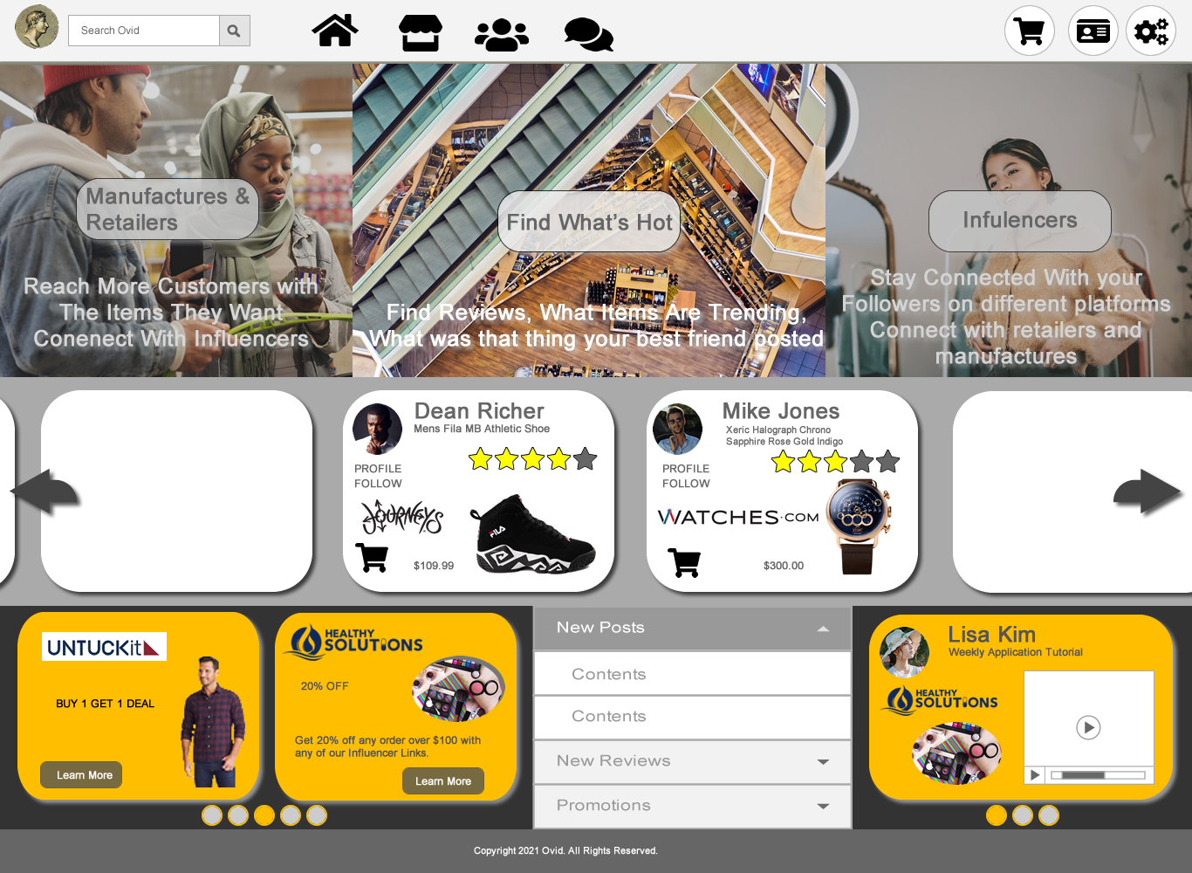

Figure Home Page - No Login

The main landing page provides information about the system in the top interactive panel. The mouse over and animation occurs, changing the bottom text fade in and out in timer. Animation stops on mouse out.

A carousel of the top trending post are displayed in the middle, the tape should self increment on a timer when not mouse over and be able to navigate back and fourth using the arrows.

Two smaller carousels are used in the last panel row, the first to display active campaigns by manufactures and retailers that have sponsored products in the system. These will work as coupons when the user buys and item from one of the affiliate, influencer, and links. The last carousel is used to display top trending new review or tutorials posted by influencers.

The center section at the bottom provides an accordion control that will display new post, new reviews, and promotions.

## Home Page with Dialogs

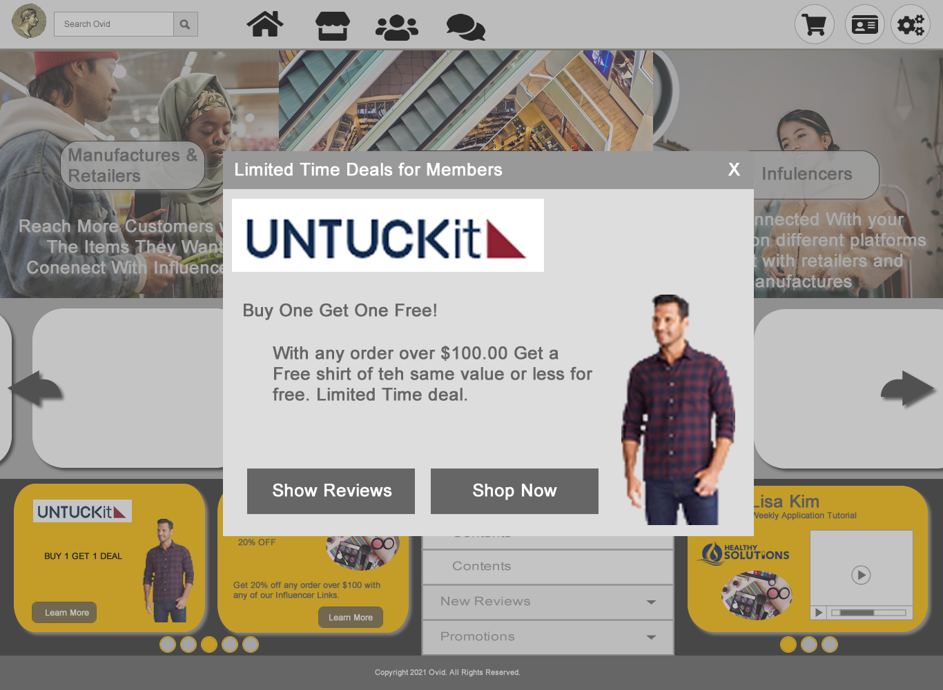

Figure Home Page with Dialog

## Home Page Full screen Tutorial / Review

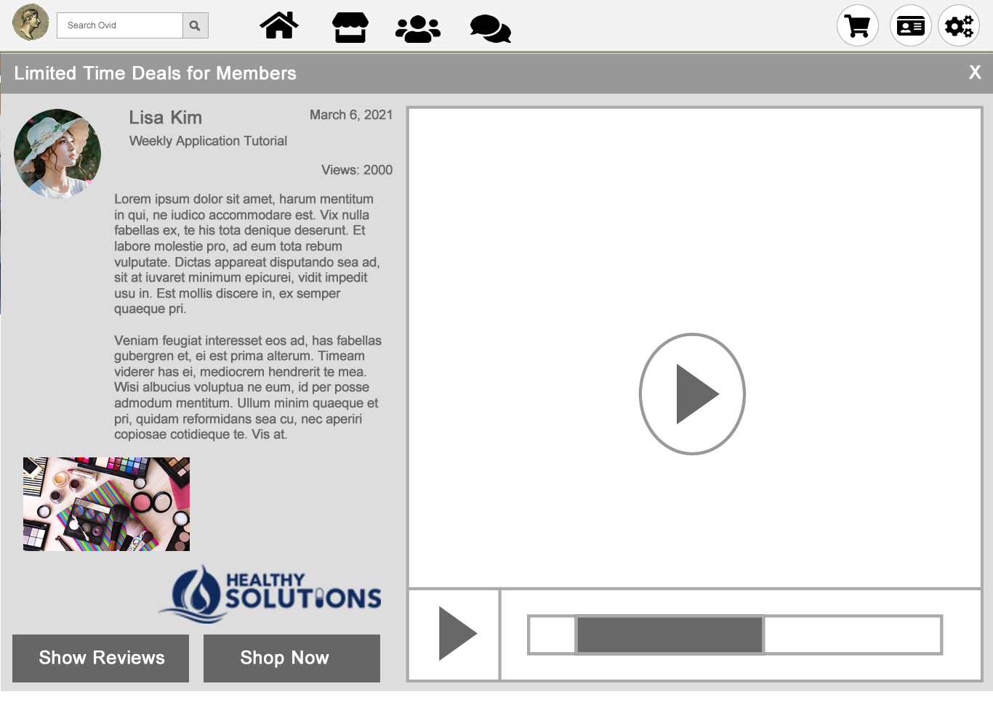

Figure Home Page Tutorial Full Page Overlay

## User Account Feed

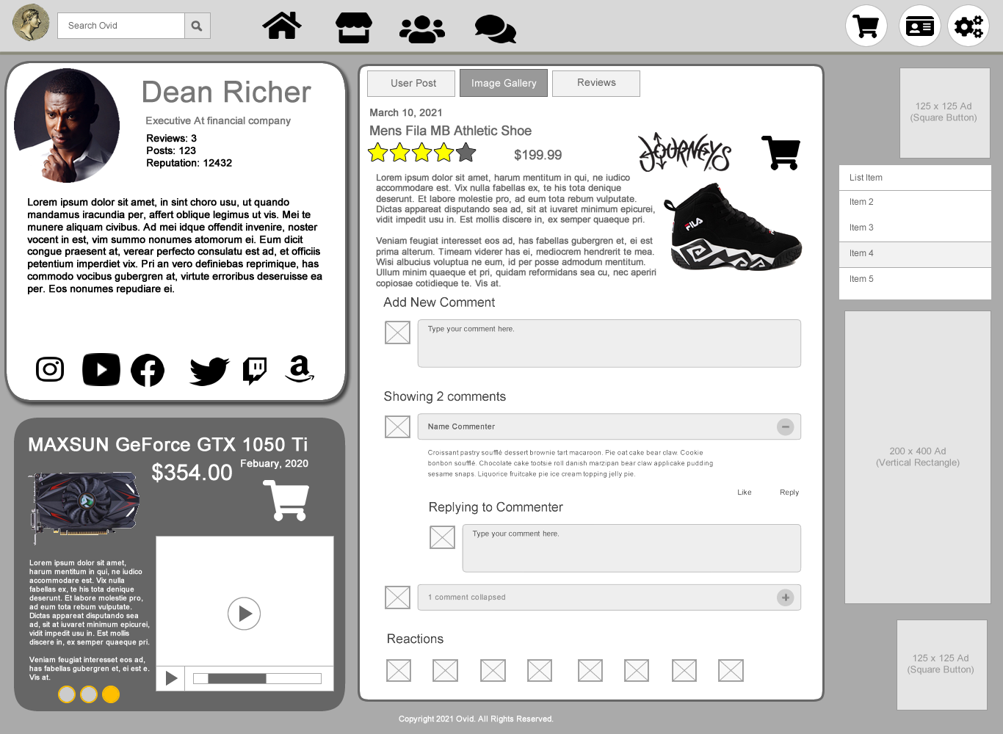

Figure Feeds Page

The feed page is the main account page people see they view a user’s account. It consist of an ID card with the general; account information and links. The second panel in the column shows the latest reviews and tutorials a person has posted. The center feed acts as the primary social media post and means for users to post their purchases and affiliate links.

The last smaller column is used for target advertising and the account navigation menu.

## People Search

# 

Figure People Search

## Product Search

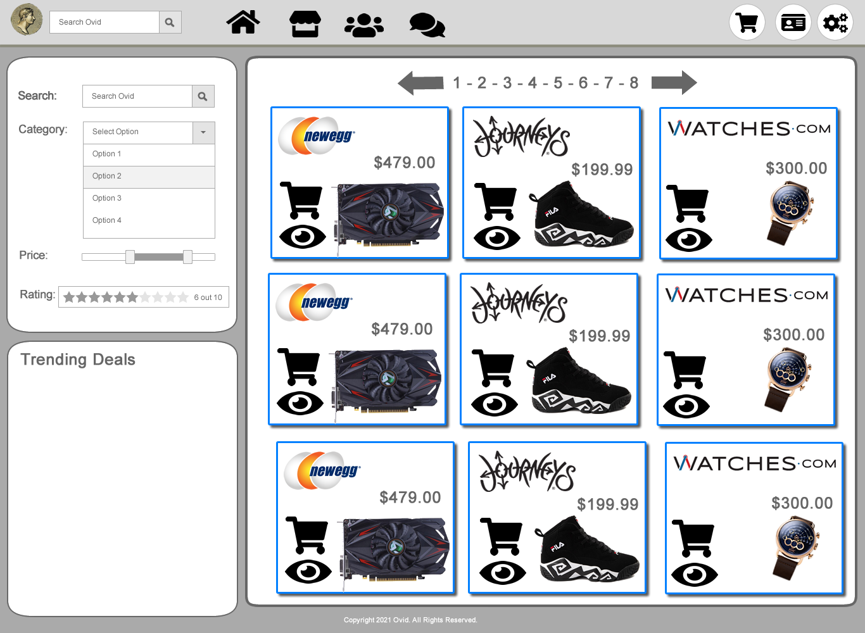

Figure Product Search

# Deployment

The main application is deployed as a web based application using DotNet 5.0. This is a cross platform package that can be deployed and run on all major web servers including IIS, Apache, Nginx, and more. The application runs on a super fast Kestrel server and proxies via the web server, or in the case of Docker provides access to application ports. The deployment depends on the scenario being used to host the application.

## Single Server Deployment

A single server deployment allows Ovid to be deployed using a sing IP and certificate. The Authentication, and API services are hosted by a single endpoint. This simplifies the deployment of the application and is only advised for evaluation and development.

The server extension are run on an empty DotNet 5.0 Web Application. This provides all the required runtime hooks to make the authentication system and the API server available on the address the Web applications is running.

## Kubernetes Deployment

The recommended production deployment is to remove the Authentication Services and API Services into their own endpoints. This provides a layer of abstraction to the security, removing calls to the authentication services from the API server. The main benefit is the ability to load balance separately different models and services of the Ovid Platform. Load balancing and dynamic pod deployment allows the system to horizontally scale at runtime.

To provide fault tolerance and load balancing the application will required three load balancers and IP pools, One for the authentication endpoint, one for the API endpoint, and a final one for the web interface. This configuration allows each major component to be scaled and balanced for server load.